Creating the XML_Reservation message flow :

Queues:

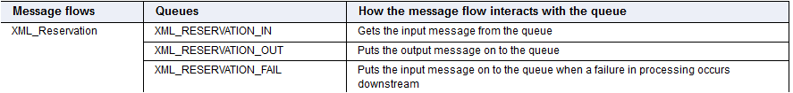

INPUTS:

Message 1: Single Messaage:

<Reservation>
<FlightDetails>
<Number>BA039</Number>
<Date>20030525</Date>
</FlightDetails>
<ListOfPassengers>
<PassengerDetails>
<FirstName>Mary</FirstName>
<LastName>Smith</LastName>
<Class>F</Class>
</PassengerDetails>
</ListOfPassengers>
<Request>S</Request>
</Reservation>

Message 2: Multiple Message:

<Reservation>
<FlightDetails>
<Number>CA937</Number>
<Date>20030525</Date>
</FlightDetails>
<ListOfPassengers>
<PassengerDetails>
<FirstName>Mary</FirstName>
<LastName>Smith</LastName>
<Class>F</Class>
</PassengerDetails>
<PassengerDetails>
<FirstName>Diane</FirstName>
<LastName>Rose</LastName>
<Class>Y</Class>
</PassengerDetails>
<PassengerDetails>
<FirstName>Debra</FirstName>
<LastName>Wiess</LastName>
<Class>Y</Class>
</PassengerDetails>
<PassengerDetails>
<FirstName>Atila</FirstName>
<LastName>Wiess</LastName>
<Class>F</Class>
</PassengerDetails>
</ListOfPassengers>
<Request>M</Request>
</Reservation>

Output 1:
<PassengerReservationResponse>
<ListOfConfirmations>
<Confirmation>
<FirstName>Mary</FirstName>
<LastName>Smith</LastName>
<Class>F</Class>
<ReservationNumber>CA937200305251</ReservationNumber>
</Confirmation>
</ListOfConfirmations>
</PassengerReservationResponse>

1. flow name: XML _Reservation

Nodes:

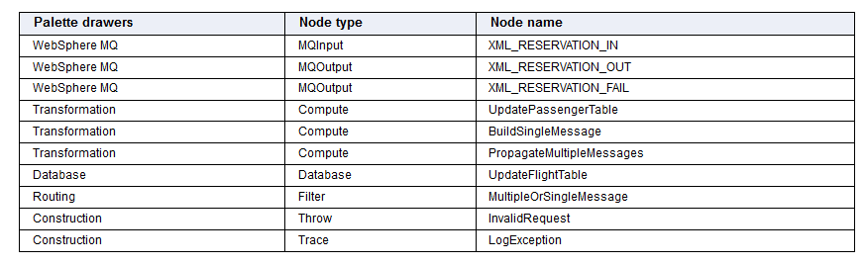

2. Connect nodes as mentioned below:

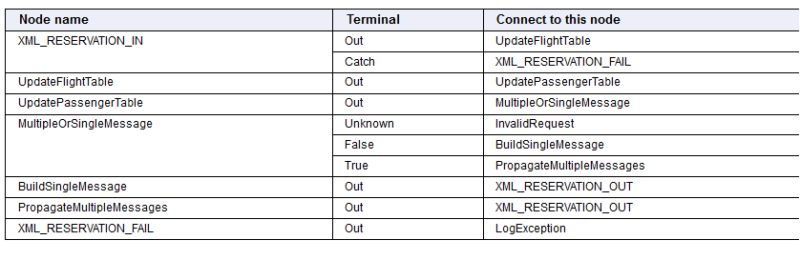

Node Properties:

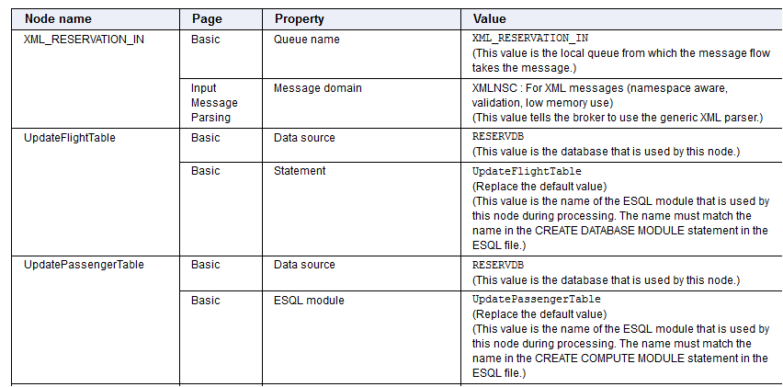

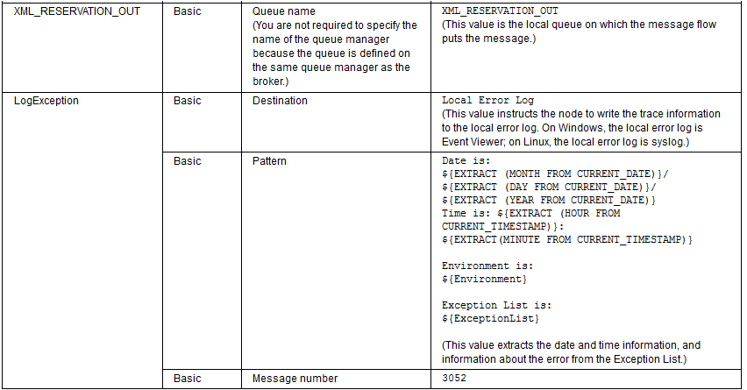

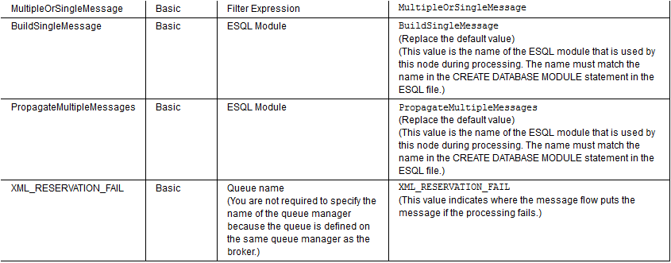

3. flow diagram :

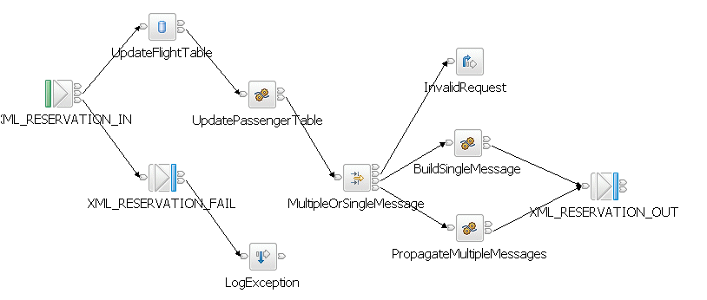

4.The XML_Reservation message flow performs the following actions:
• The XML_RESERVATION_IN node gets the input message from the XML_RESERVATION_IN queue, and identifies the message as being a self-defining XML message.

• The XML_RESERVATION_IN node fully parses the message by using the XMLNSC parser, then passes the input message through the Out terminal to the UpdateFlightTable node. Alternatively, if an exception is produced downstream and the message is rolled back, the node passes the input message through the Catch terminal to the XML_RESERVATION_FAIL node, which passes the message to the LogException node. The LogException node then writes the error to the local error log, which is the Event Viewer on Windows, and the syslog on Linux.

• The UpdateFlightTable node checks the XMLFLIGHTTB table to see if the requested seats are available, then updates the XMLFLIGHTTB table to show that the seats are allocated and fewer seats are now available.

• The UpdateFlightTable node inserts the value of the RESERVATIONSEQNO from the XMLFLIGHTTB table into an Environment variable, which is passed to the UpdatePassengerTable node. The UpdateFlightTable node also puts into an Environment variable the number of seats remaining in each class.

• The UpdateFlightTable node passes the input message through the Out terminal to the UpdatePassengerTable node.

• The UpdatePassengerTable node gets the passenger list from the input message and the flight data from the Environment tree, and adds the names and reservation information of the new passengers to the XMLPASSENGERTB table in the RESERVDB database.

• The UpdatePassengerTable node creates and assigns a unique reservation number to each passenger. The reservation number is made up from:
FlightNumber + FlightDate + RESERVATIONSEQNO
The value in RESERVATIONSEQNO is taken from the Environment variable received from the UpdateFlightTable node. For example, Mary Smith's Reservation Number is CA937200305251. The UpdatePassengerTable node updates the XMLPASSENGERTB table with these reservation numbers.
• The UpdatePassengerTable node passes the input message through the Out terminal to the MultipleOrSingleMessage node.

• The MultipleOrSingleMessage node checks the input message field called Request and determines where to pass the message next:
• If the message goes to the PropagateMultipleMessages node, the PropagateMultipleMessages node creates a reply message for one of the passengers listed in the input message, then passes the reply through the Out terminal to the XML_RESERVATION_OUT node. The PropagateMultipleMessages node creates a similar reply message for each passenger listed in the input message.
• If the message goes to the BuildSingleMessage node, the BuildSingleMessage node creates a single reply message containing a list of the passengers and their reservation numbers, then passes the reply through the Out terminal to the XML_RESERVATION_OUT node.

• The XML_RESERVATION_OUT node puts the reply messages on the XML_RESERVATION_OUT queue.

Database tables:

Run below data base script:
CONNECT TO RESERVDB
DROP TABLE XMLFLIGHTTB
CREATE TABLE XMLFLIGHTTB (FLIGHTDATE CHAR(8) NOT NULL, FLIGHTNO CHAR(5) NOT NULL, ECONOMICCLASS INTEGER NOT NULL, FIRSTCLASS INTEGER NOT NULL, TOTALECONOMIC INTEGER NOT NULL, TOTALFIRST INTEGER NOT NULL, ECONOMICPRICE INTEGER NOT NULL, FIRSTPRICE INTEGER NOT NULL, STARTPOINT CHAR(20) NOT NULL, ENDPOINT CHAR(20) NOT NULL, RESERVATIONSEQNO INTEGER NOT NULL, CONSTRAINT FLIGHT_UNIQ UNIQUE(FLIGHTDATE, FLIGHTNO))
INSERT INTO XMLFLIGHTTB VALUES('20030218', 'CA935', 0, 0, 200, 50, 200, 300, 'BEIJING', 'LONDON', 0)
INSERT INTO XMLFLIGHTTB VALUES ('20030525', 'BA039', 0, 0, 180, 40, 220, 320, 'LONDON', 'BEIJING', 0)
INSERT INTO XMLFLIGHTTB VALUES('20030525', 'CA937', 0, 0, 200, 50, 200, 300, 'BEIJING', 'LONDON', 0)
INSERT INTO XMLFLIGHTTB VALUES('20030219', 'BA039', 0, 0, 180, 40, 220, 320, 'LONDON', 'BEIJING', 0)
DROP TABLE XMLPASSENGERTB
CREATE TABLE XMLPASSENGERTB (LASTNAME CHAR(20) NOT NULL, FIRSTNAME CHAR(20) NOT NULL, FLIGHTNO CHAR(5) NOT NULL, FLIGHTDATE CHAR(8) NOT NULL, CLASSTYPE CHAR(1) NOT NULL, RESERVATIONNO VARCHAR(40) NOT NULL, PRIMARY KEY(RESERVATIONNO))
TERMINATE

Database name: RESERVDB
Table Name: XMLFLIGHTTB

FLIGHT  DATE | FLIGHTNO | ECONOMIC  CLASS | FIRST  CLASS | TOTALE  CONOMIC | TOTAL  FIRST | ECONOMIC  PRICE | FIRST  PRICE

Database: RESERVDB
Table Name: XMLPASSENGERTB

LASTNAME | FIRSTNAME | FLIGHTNO | FLIGHTDATE | CLASSTYPE | RESERVATIONNO

Code In database Node:

CREATE DATABASE MODULE UpdateFlightTable
CREATE FUNCTION Main() RETURNS BOOLEAN
BEGIN
-- populate the environment with flight info from the database

SET Environment.Variables =
THE (SELECT T.* FROM Database.XMLFLIGHTTB AS T
WHERE T.FLIGHTDATE = Root.XMLNSC.Reservation.FlightDetails.FlightDate
AND T.FLIGHTNO = Root.XMLNSC.Reservation.FlightDetails.FlightNumber);

DECLARE ref REFERENCE TO Root.XMLNSC.Reservation.ListOfPassengers.PassengerDetails[1];

-- track the remaining number of seats

SET Environment.Variables.EconomyClassRemain = CAST(Environment.Variables.TOTALECONOMIC AS INTEGER);
SET Environment.Variables.FirstClassRemain = CAST(Environment.Variables.TOTALFIRST AS INTEGER);

-- loop through the request, counting the passengers and checking capacity
SET Environment.Variables.NoPassengers = 0;
WHILE LASTMOVE(ref) DO -- check that the REFERENCE is still valid
IF ref.Class = 'F' THEN
IF Environment.Variables.FirstClassRemain >= 1 THEN
SET Environment.Variables.FirstClassRemain = Environment.Variables.FirstClassRemain - 1;
SET Environment.Variables.FIRSTCLASS = Environment.Variables.FIRSTCLASS + 1;
SET Environment.Variables.NoPassengers =Environment.Variables.NoPassengers + 1;

ELSE
THROW USER EXCEPTION MESSAGE 2949 VALUES('Number of passengers exceeds capacity');
END IF;
END IF;
IF ref.Class = 'Y' THEN
IF Environment.Variables.EconomyClassRemain >= 1 THEN
SET Environment.Variables.EconomyClassRemain = Environment.Variables.EconomyClassRemain - 1;
SET Environment.Variables.ECONOMICCLASS = Environment.Variables.ECONOMICCLASS + 1;

SET Environment.Variables.NoPassengers = Environment.Variables.NoPassengers + 1;

ELSE
THROW USER EXCEPTION MESSAGE 2949 VALUES('Number of passengers exceeds capacity');
END IF;
END IF;
MOVE ref NEXTSIBLING REPEAT NAME; -- increment the loop condition
END WHILE;

-- update the database with the decreased seat availability for the flight

UPDATE Database.XMLFLIGHTTB AS T
SET ECONOMICCLASS = Environment.Variables.ECONOMICCLASS,
TOTALECONOMIC = Environment.Variables.EconomyClassRemain,
FIRSTCLASS = Environment.Variables.FIRSTCLASS,
TOTALFIRST = Environment.Variables.FirstClassRemain
WHERE T.FLIGHTDATE = Root.XMLNSC.Reservation.FlightDetails.FlightDate
AND T.FLIGHTNO = Root.XMLNSC.Reservation.FlightDetails.FlightNumber;

RETURN TRUE;
END;
END MODULE;

Code in compute node:

CREATE COMPUTE MODULE UpdatePassengerTable
CREATE FUNCTION Main() RETURNS BOOLEAN
BEGIN
SET OutputRoot = InputRoot;
DECLARE I INTEGER 1;
DECLARE J INTEGER Environment.Variables.NoPassengers;
DECLARE resno CHARACTER;
WHILE I <= J DO -- loop through the passengers
SET Environment.Variables.RESERVATIONSEQNO = Environment.Variables.RESERVATIONSEQNO + 1;

-- generate the reservation number (unique)

SET resno = (InputRoot.XMLNSC.Reservation.FlightDetails.FlightNumber ||
InputRoot.XMLNSC.Reservation.FlightDetails.FlightDate ||
CAST (Environment.Variables.RESERVATIONSEQNO AS CHAR));

-- insert a row into the database to track this reservation

INSERT INTO Database.XMLPASSENGERTB (LASTNAME, FIRSTNAME, FLIGHTNO, FLIGHTDATE, CLASSTYPE, RESERVATIONNO)
VALUES(InputRoot.XMLNSC.Reservation.ListOfPassengers.PassengerDetails[I].LastName,
InputRoot.XMLNSC.Reservation.ListOfPassengers.PassengerDetails[I].FirstName,
InputRoot.XMLNSC.Reservation.FlightDetails.FlightNumber,
InputRoot.XMLNSC.Reservation.FlightDetails.FlightDate,
InputRoot.XMLNSC.Reservation.ListOfPassengers.PassengerDetails[I].Class, resno);

-- report the reservation number in the output message

SET OutputRoot.XMLNSC.Reservation.ListOfPassengers.PassengerDetails[I].ReservationNumber = resno;
SET I = I + 1;
END WHILE;

-- update the sequence number in the database

UPDATE Database.XMLFLIGHTTB AS T
SET RESERVATIONSEQNO = Environment.Variables.RESERVATIONSEQNO;
RETURN TRUE;
END;
END MODULE;

Filter Node:

CREATE FILTER MODULE MultipleOrSingleMessage
CREATE FUNCTION Main() RETURNS BOOLEAN
BEGIN
IF Root.XMLNSC.Reservation.Request = 'M' THEN
RETURN TRUE;
END IF;
IF Root.XMLNSC.Reservation.Request = 'S' THEN
RETURN FALSE;
END IF;
RETURN UNKNOWN;
END;
END MODULE;

Compute node:

CREATE COMPUTE MODULE BuildSingleMessage
CREATE FUNCTION Main() RETURNS BOOLEAN
BEGIN
SET OutputRoot = InputRoot;
SET OutputRoot.XMLNSC.Reservation = NULL;

SET OutputRoot.XMLNSC.PassengerReservationResponse.ListOfConfirmations.ClassF.Confirmation[] = (SELECT X.FirstName, X.LastName AS Surname, X.ReservationNumber FROM InputRoot.XMLNSC.Reservation.ListOfPassengers.PassengerDetails[] AS X
WHERE UPPER(X.Class) = 'F');

SET OutputRoot.XMLNSC.PassengerReservationResponse.ListOfConfirmations.ClassY.Confirmation[] =
(SELECT X.FirstName, X.LastName AS Surname, X.ReservationNumber
FROM InputRoot.XMLNSC.Reservation.ListOfPassengers.PassengerDetails[] AS X
WHERE UPPER(X.Class) = 'Y');
RETURN TRUE;
END;
END MODULE;

Compute node:

CREATE COMPUTE MODULE PropagateMultipleMessages
CREATE FUNCTION Main() RETURNS BOOLEAN
BEGIN
DECLARE I INTEGER 1;
DECLARE J INTEGER Environment.Variables.NoPassengers;
WHILE I <= J DO
SET OutputRoot = InputRoot;
SET OutputRoot.XMLNSC.Reservation = NULL;
SET OutputRoot.XMLNSC.PassengerReservationResponse.ListOfConfirmations.Confirmation =
InputRoot.XMLNSC.Reservation.ListOfPassengers.PassengerDetails[I];
PROPAGATE;
SET I = I + 1;
END WHILE;
RETURN FALSE; -- returning false stops automatic propagation
END;
END MODULE;

Executed Code :

CREATE DATABASE MODULE UpdateFlightTable
CREATE FUNCTION Main() RETURNS BOOLEAN
BEGIN
SET Environment.Variables=THE(SELECT T.* FROM Database.UPENDER.XMLFLIGHTTB AS T WHERE T.FLIGHTDATE=Root.XMLNSC.Reservation.FlightDetails.Date AND T.FLIGHTNO=Root.XMLNSC.Reservation.FlightDetails.Number );

DECLARE ref REFERENCE TO Root.XMLNSC.Reservation.ListOfPassengers.PassengerDetails[1];

SET Environment.Variables.EconomyClassRemain=CAST(Environment.Variables.TOTALECONOMIC AS INTEGER);
SET Environment.Variables.FirstClassRemain=CAST(Environment.Variables.TOTALFIRST AS INTEGER);

SET Environment.Variables.NoPassengers=0;
WHILE LASTMOVE(ref) DO

IF ref.Class='F' THEN
IF Environment.Variables.FirstClassRemain>=1 THEN
SET Environment.Variables.FirstClassRemain=Environment.Variables.FirstClassRemain-1;
SET Environment.Variables.FIRSTCLASS=Environment.Variables.FIRSTCLASS+1;
SET Environment.Variables.NoPassengers= Environment.Variables.NoPassengers+1;
ELSE
THROW USER EXCEPTION MESSAGE 2949 VALUES ('NUMBER OF PASSANGES EXCEEDS CAPACITY');
END IF;

END IF;

IF ref.Class='Y' THEN
IF Environment.Variables.EconomyClassRemain>=1 THEN
SET Environment.Variables.EconomyClassRemain=Environment.Variables.EconomyClassRemain-1;
SET Environment.Variables.ECONOMYCLASS=Environment.Variables.ECONOMYCLASS+1;
SET Environment.Variables.NoPassengers= Environment.Variables.NoPassengers+1;
ELSE
THROW USER EXCEPTION MESSAGE 2949 VALUES ('NUMBER OF PASSANGES EXCEEDS CAPACITY');

END IF;

END IF;

MOVE ref NEXTSIBLING REPEAT NAME;

END WHILE;

UPDATE Database.UPENDER.XMLFLIGHTTB AS T SET ECONOMICCLASS=Environment.Variables.ECONOMICCLASS,
TOTALECONOMIC=Environment.Variables.EconomyClassRemain,
FIRSTCLASS=Environment.Variables.FIRSTCLASS,
TOTALFIRST=Environment.Variables.FirstClassRemain
WHERE T.FLIGHTDATE=Root.XMLNSC.Reservation.FlightDetails.Date AND T.FLIGHTNO=Root.XMLNSC.Reservation.FlightDetails.Number ;

RETURN TRUE;
END;

END MODULE;

CREATE COMPUTE MODULE UpdatePassengerTable
CREATE FUNCTION Main() RETURNS BOOLEAN
BEGIN
SET OutputRoot=InputRoot;
DECLARE i INTEGER 1;
DECLARE j INTEGER Environment.Variables.NoPassengers;
DECLARE resno CHARACTER;
WHILE i<=j DO

SET Environment.Variables.RESERVATIONSEQNO=Environment.Variables.RESERVATIONSEQNO+1;

SET resno=(InputRoot.XMLNSC.Reservation.FlightDetails.Number || InputRoot.XMLNSC.Reservation.FlightDetails.Date|| CAST(Environment.Variables.RESERVATIONSEQNO AS CHARACTER) );

INSERT INTO DataSource.UPENDER.XMLPASSENGERTB (LASTNAME,FIRSTNAME,FLIGHTNO,FLIGHTDATE,CLASSTYPE,RESERVATIONNO ) VALUES (InputRoot.XMLNSC.Reservation.ListOfPassengers.PassengerDetails[i] .LastName,InputRoot.XMLNSC.Reservation.ListOfPassengers.PassengerDetails[i] .FirstName,InputRoot.XMLNSC.Reservation.FlightDetails.Number,InputRoot.XMLNSC.Reservation.FlightDetails.Date, InputRoot.XMLNSC.Reservation.ListOfPassengers.PassengerDetails[i] .Class,resno);
SET OutputRoot.XMLNSC.Reservation.ListOfPassengers.PassengerDetails[i] .Reservationnumber=resno;
SET i=i+1;
END WHILE;
UPDATE Database.UPENDER.XMLFLIGHTTB AS T SET RESERVATIONSEQNO =Environment.Variables.RESERVATIONSEQNO;

RETURN TRUE;
END;

CREATE PROCEDURE CopyMessageHeaders() BEGIN
DECLARE I INTEGER 1;
DECLARE J INTEGER;
SET J = CARDINALITY(InputRoot.*[]);
WHILE I < J DO
SET OutputRoot.*[I] = InputRoot.*[I];
SET I = I + 1;
END WHILE;
END;

CREATE PROCEDURE CopyEntireMessage() BEGIN
SET OutputRoot = InputRoot;
END;
END MODULE;

CREATE FILTER MODULE MultipleOrSingleMessage
CREATE FUNCTION Main() RETURNS BOOLEAN
BEGIN
IF Root.XMLNSC.Reservation.Request='M' THEN
RETURN TRUE;

END IF;
IF Root.XMLNSC.Reservation.Request='S' THEN
RETURN FALSE;
END IF;

RETURN TRUE;
END;

END MODULE;

CREATE COMPUTE MODULE BuildSingleMessage
CREATE FUNCTION Main() RETURNS BOOLEAN
BEGIN

SET OutputRoot=InputRoot;
SET OutputRoot.XMLNSC.Reservation=NULL;

IF InputRoot.XMLNSC.Reservation.ListOfPassengers.PassengerDetails.Class=UPPER('F') THEN
SET OutputRoot.XMLNSC.PassengerReservationResponse.ListOfConfirmations.Confirmation[]=InputRoot.XMLNSC.Reservation.ListOfPassengers.PassengerDetails[];
ELSEIF InputRoot.XMLNSC.Reservation.ListOfPassengers.PassengerDetails.Class=UPPER('Y') THEN
SET OutputRoot.XMLNSC.PassengerReservationResponse.ListOfConfirmations.Confirmation[]=InputRoot.XMLNSC.Reservation.ListOfPassengers.PassengerDetails[];
END IF;
--SET OutputRoot.XMLNSC.PassengerReservationResponse.ListOfConfirmations.Confirmation=THE(SELECT X.FirstName ,X.LastName AS SurName,X.Reservationnumber FROM InputRoot.XMLNSC.Reservation.ListOfPassengers.PassengerDetails[] AS X WHERE UPPER(X.Class)='F');
--SET OutputRoot.XMLNSC.PassengerReservationResponse.ListOfConfirmations.Confirmation=THE(SELECT X.FirstName ,X.Lastname AS SurName,X.Reservationnumber FROM InputRoot.XMLNSC.Reservation.ListOfPassengers.PassengerDetails[] AS X WHERE UPPER(X.Class)='Y');

RETURN TRUE;
END;

CREATE PROCEDURE CopyMessageHeaders() BEGIN
DECLARE I INTEGER 1;
DECLARE J INTEGER;
SET J = CARDINALITY(InputRoot.*[]);
WHILE I < J DO
SET OutputRoot.*[I] = InputRoot.*[I];
SET I = I + 1;
END WHILE;
END;

CREATE PROCEDURE CopyEntireMessage() BEGIN
SET OutputRoot = InputRoot;
END;
END MODULE;

CREATE COMPUTE MODULE PropagateMultipleMessage
CREATE FUNCTION Main() RETURNS BOOLEAN
BEGIN
DECLARE i INTEGER 1;
DECLARE j INTEGER Environment.Variables.NoPassengers;
WHILE i<=j DO
SET OutputRoot=InputRoot;
SET OutputRoot.XMLNSC.Reservation=NULL;
SET OutputRoot.XMLNSC.PassengerReservationResponse.ListOfConfirmations.Confirmation=InputRoot.XMLNSC.Reservation.ListOfpassengers.passengerDetails[i];
PROPAGATE;
SET i=i+1;

END WHILE;

RETURN FALSE;
END;

CREATE PROCEDURE CopyMessageHeaders() BEGIN
DECLARE I INTEGER 1;
DECLARE J INTEGER;
SET J = CARDINALITY(InputRoot.*[]);
WHILE I < J DO
SET OutputRoot.*[I] = InputRoot.*[I];
SET I = I + 1;
END WHILE;
END;

CREATE PROCEDURE CopyEntireMessage() BEGIN
SET OutputRoot = InputRoot;
END;
END MODULE;
db2 => connect to XMLDB

Database Connection Information

Database server = DB2/NT 9.7.0
SQL authorization ID = UPENDER
Local database alias = XMLDB

db2 => GRANT ALL ON XMLFLIGHTTB to db2admin
DB20000I The SQL command completed successfully.
db2 => GRANT ALL ON XMLPASSENGERTB to db2admin
DB20000I The SQL command completed successfully.
db2 =>

